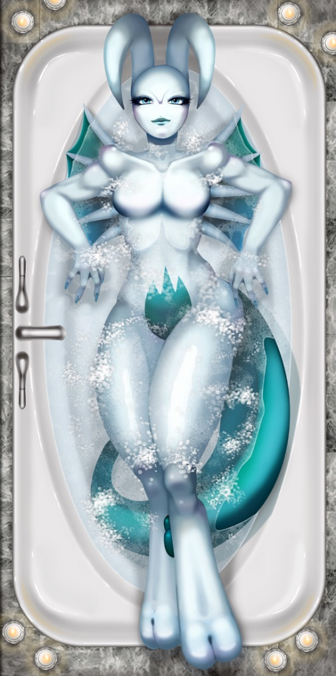
Amidst the Evening Bubbles

Such a freedom frame
Relaxed by the water
Her desire has become that of a wish
Solitude.
Peaceful Bliss.
The echo of the feeling ranged in her eyes
What a strong feature to be seen
So powerful a body, without a wrinkle of tension lit through her figure.
How both frighteningly beautiful and completely surreal
As if a lucid dream was given a form
A dragon and psychic principle stark in her revue
Not one of anything more than an eased sigh
As she lays back, enjoying the simple fine tuned part of life
Bathing is a wonderful sensation
And one even better when enjoyed by a lady of her person
Lady Swadeaqua.

~Quentix Starwing

