Ascent As Seen Kujiku

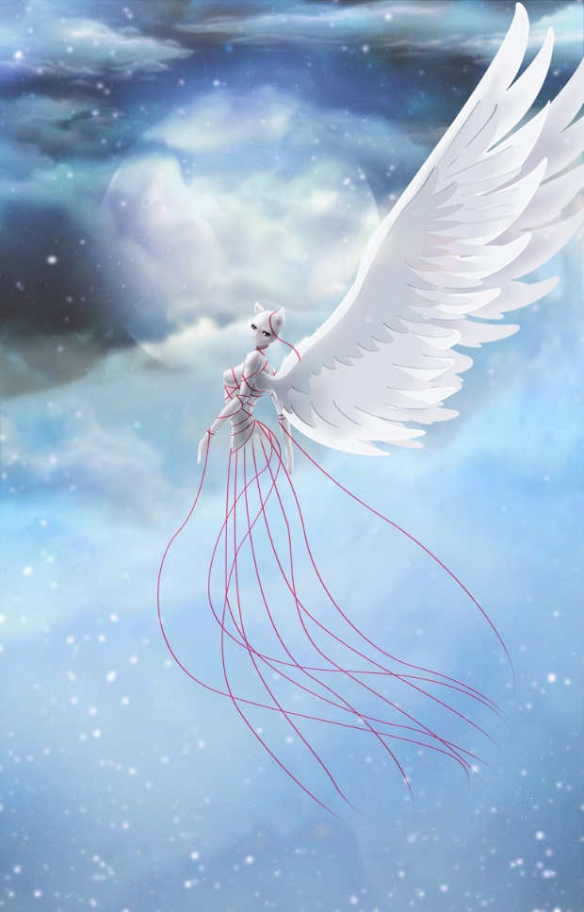
Red Strings Ascent
Like a breath from the great mother
Gifts are they to be seen by
Transcending even that of the fates
Is the angelic herald a flicker of doom?
Thumping beats thine heart in echos
Mere moments that follow the height gained
Wings beat once and then twice
Bonded to these strings of sublime
Always fated to wander the sanctity
Even he shall do nothing but look upon it
Below and yet beyond
Humble and but bold
Entangled and embraced
Secretly sacred and yet simpering
Secrets known by the pattern weaver
As benevolence meets honor
Faith meets justice
Embedded within one
Bound to her by traits that stand
Like a faith of simply being
Just let her soar...

~Quentix Starwing

