In the Shade of Aqua Light

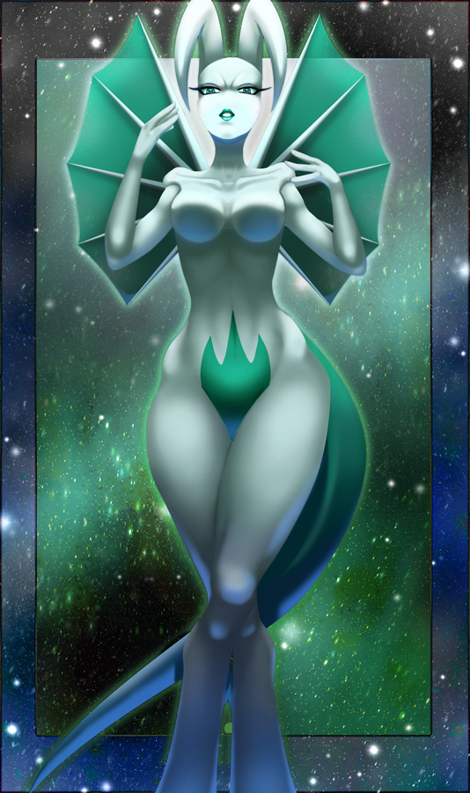
Before the glimmering touch
Angelic kissed Nightmare
Bright heart looming before determined gaze
Soft touched, whispers of smoothness
The first thoughts that come to the eyes of the beholder
Captivating. This is the first thing that happens to thee
Ensnared. Making the viewer a victim without every touching the soul
Lulled. If only by the entrancing gaze of the beauty before thy view
Visage. One beyond words, nothing that can be invited
A Step. Taken in thy direction sends the mind a thrumming
Wings like a haven on light upon the horizon
Eyes focused and beyond a gallant beauty
Posture as if a living, statuesque form kissed by gods
Legs so powerful and elegant as songbird's wings on the air
Presence like a predator, softened only by intent and bemusement of the one now staring
Tail guided by grace of a prehensile nature while swaying along
Collectively it is beyond words, beyond measure, beyond merely that...she is a Mewthree.

~Quentix Starwing

