To Gaze at Infinity's Edge
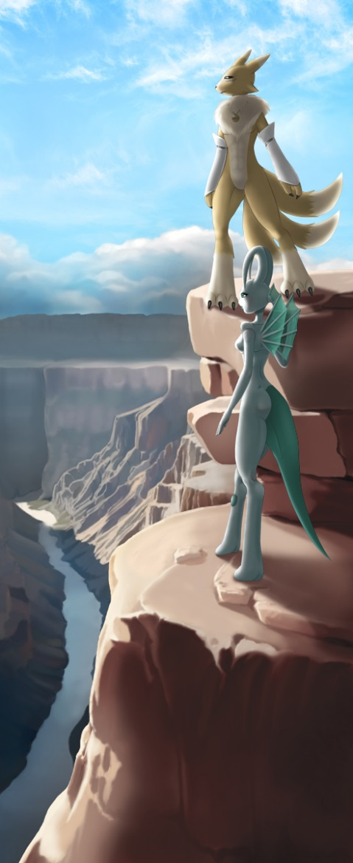
Over an edge where one may stand
The precipice seems wide and gaunt
Jagged and unforgiving as the brunt of life can seem
Perhaps unfounded, the one is not unhurt when looking at its edge
But held within its grasp
That is the joy of a pair
There one becomes two
At first unknown in company
When made aware a shock to the system rises
It is met by a tempering
Something between wills
Where the blue's edge embraces the brown
And light clears the shade, a sigh rises from one in yellow
A similar color to the light that had wandered the river blue
Scaled the stones anew, with a vigor undaunted by the task
In free stands curled horns, free wings, and a gentle gaze looks to the skies
For peace? Who can say
For duty? Who would know
For Honor? Who will find it
Perhaps just to be
Simply to hold at a breath's edge, a shared dance of infinity
Not with physical effort, if merely with company
Not through tangle of words, if merely through realization of place
There company is welcome and embraced by acknowledgement
A single look between the pair for a moment, before eyes shall wander in wonder
With ease in the heart and of the mind, they simply shall hold onto
To gaze at Infinity's edge, with hearts free and minds unhindered.

~Quentix Starwing

