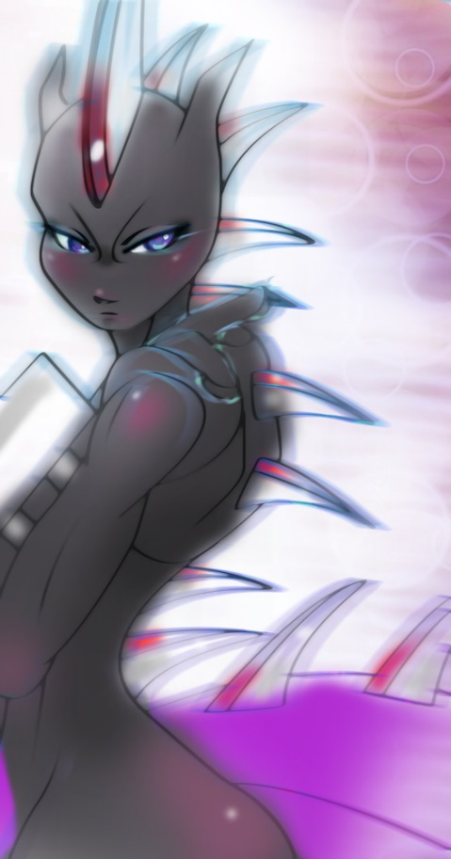
To Stagger In A Moment

From a glance all one can do is gather
But a single moment that is far to fathom
A glance that holds a strong and grasping moment
Not unlike a breath or a gasp
The sight that speaks 1000 words
Filtered by the slowdown of time and space
The moment is captured in a pastel painting
As if you were but a single piece who exists
Like a deal brokered, the feelings that remain are held hostage
That menacing glare that stole the beat of a heart
The thought from a mind
Taken hostage by the foolish whims of a mind
It was all but a passing glance, nothing but this overt fascination
With her, Mewblade, and where she stands.

~Quentix Starwing

